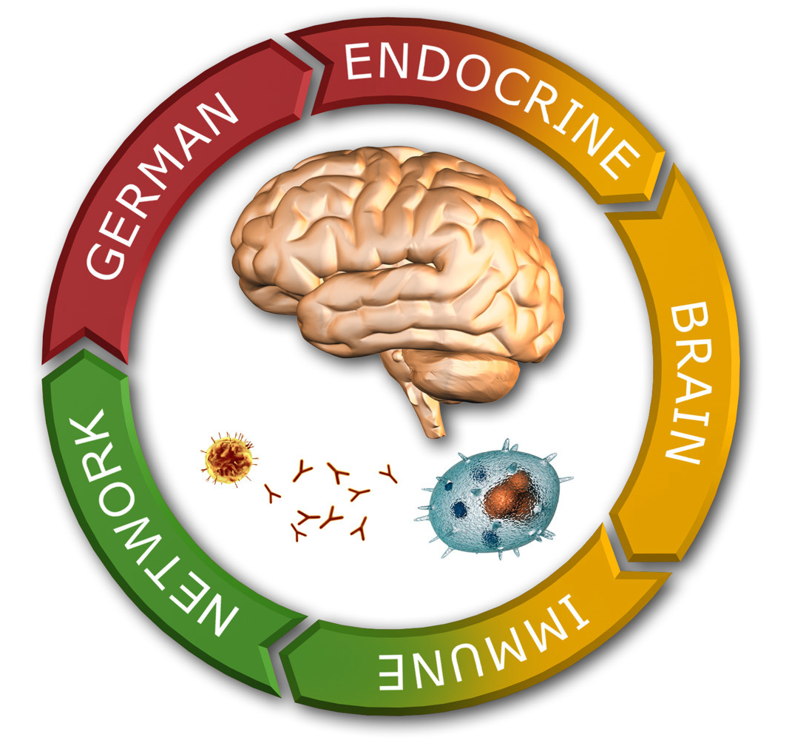

12th GEBIN Educational Course
September 27th-28th 2023

REGISTRATION

Last name

First name

Address

Phone Nr.

e-mail address

Responsible Professor/ working group

Degree/stage of Studium¹

I am interested in this Course because…

I intend to participate at the GEBIN Meeting (yes/no)
I request financial support to cover the registration fee for the GEBIN Meeting²

I would like to do a short presentation at the Networking Session³

Title:

¹ For example:
- Student of Human Biology 8th. Semester
- Doing Masterarbeit (please specify field, for example Neurosciences)
- PhD Student (please specify since when are you doing your PhD and in which subject)
- Post-Doc (please specify since when are you Post-Doc and in which subject are you working)

² If yes, please, attach a short note from your supervisor stating the need for financial support. We will be able to inform you if your request can be fulfilled only when the capacity of the course is completed.

³ If yes, please indicate a title for your presentation.

